SPSGP-78835-Virtual Internship - Android Application Development Using Kotlin

***Name: Naman Kakkar SBID:*** SB20220174278

**Project: Grocery App**

# Introduction

## Overview

As we can't remember everything, users frequently forget to buy the things they want to buy. However, with the assistance of this app, you can make a list of the groceries you intend to buy so that you don't forget anything.

## Purpose

Helps the users to remember their list of groceries which they need to buy by creating a list and also calculates the price of items based on the price user provides of one quantity.

# Literature Survey

## Existing problem

There are many pre-existing grocery list apps, but all of them don’t get worthy organic traﬃc due to the complicated user-interface and various layers of authentication/security.

## Proposed solution

A broad age group operates such apps; therefore the user interface must be very basic. Such apps are downloaded by the user for convenience, so we must not add too many security layers, as we know that security comes at the cost of convenience. In this project, we are using MVVM (Model View ViewModel) for architectural patterns, Room for database, Co-routines and RecyclerView to display the list of items.

# Theoretical Analysis

## Hardware / Software designing

For developing this project we require:

Android Studio

Knowledge about KOTLIN Language and android development

# Experimental Investigations

While creating the project I got to learn about a few parts of android that were extremely essential in the creation of the project. Some of them are listed below with brief about them.

1. MVVM (Model View ViewModel: MVVM architecture in android is used to give structure to the project’s code and understand code easily. MVVM is an architectural design pattern in android. MVVM treat Activity classes and XML ﬁles as View. This design pattern completely separate UI from its logic. Here is an image to quickly understand MVVM.
2. ROOM DataBase: Room persistence library is a database management library and it is used to store the data of apps like grocery item name, grocery item quantity, and grocery item price. Room is a cover layer on SQLite which helps to perform the operation on the database easily.
3. RecyclerView: It is a container and it is used to display the collection of data in a large amount of data set that can be scrolled very effectively by maintaining a limited number of views.
4. Co-routines: They are a lightweight thread, we use a co-routine to perform an operation on other threads, by this our main thread doesn’t block and our app doesn’t crash.

# Flowchart

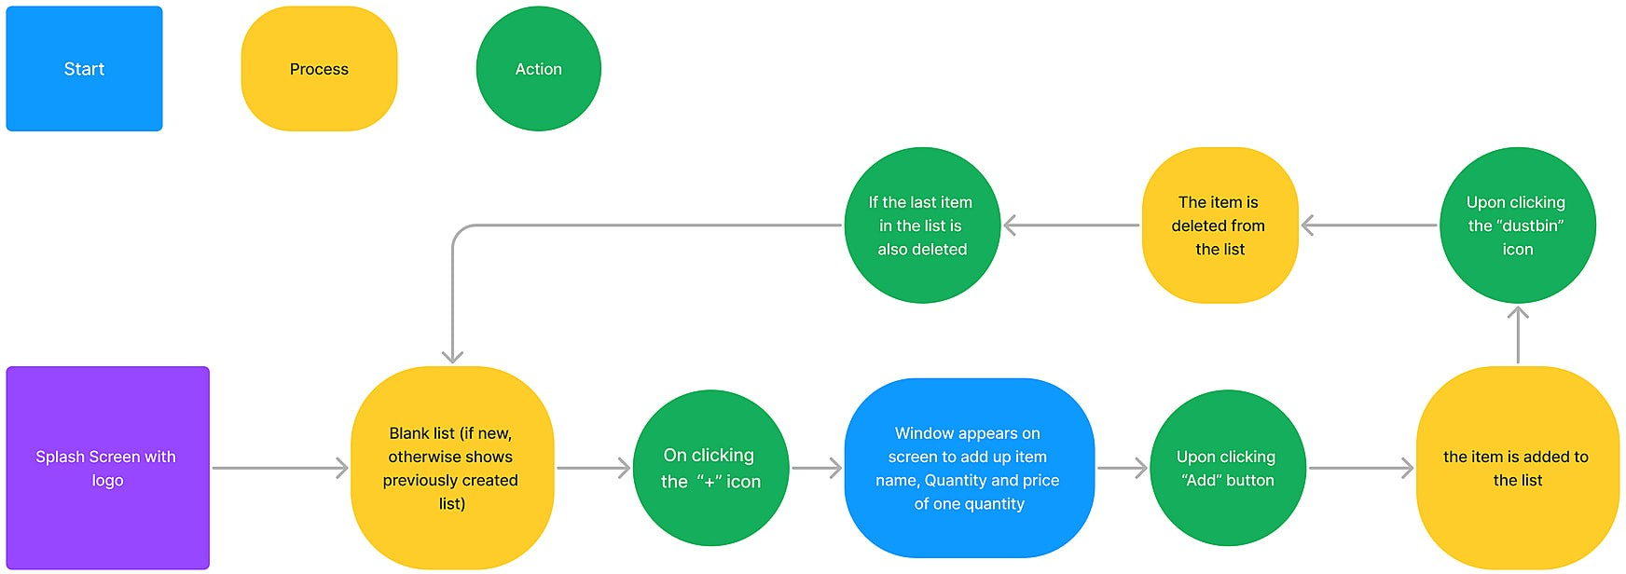

**Result:**

## Screenshots of the application:

* + 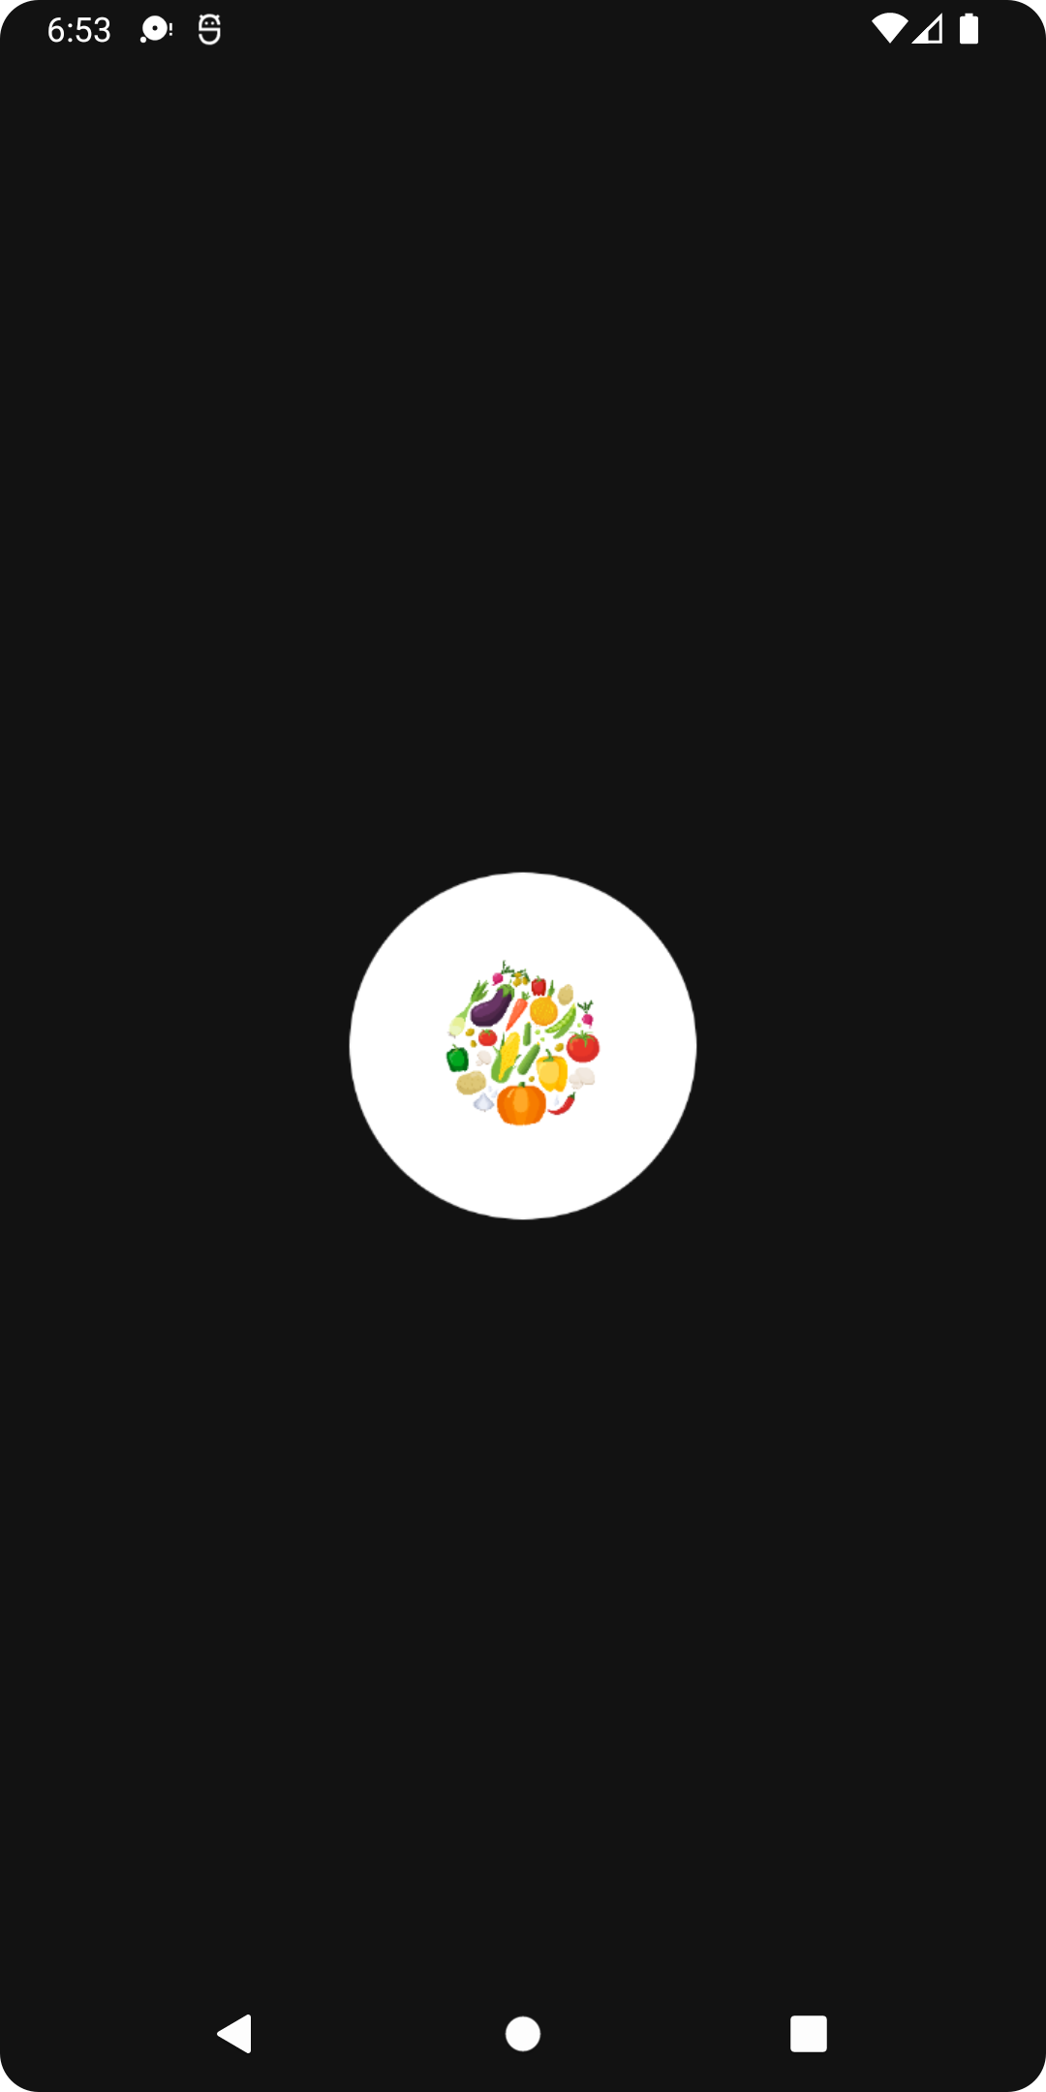**Splash screen of the app with groceries logo**

## Adding items to grocery list

* 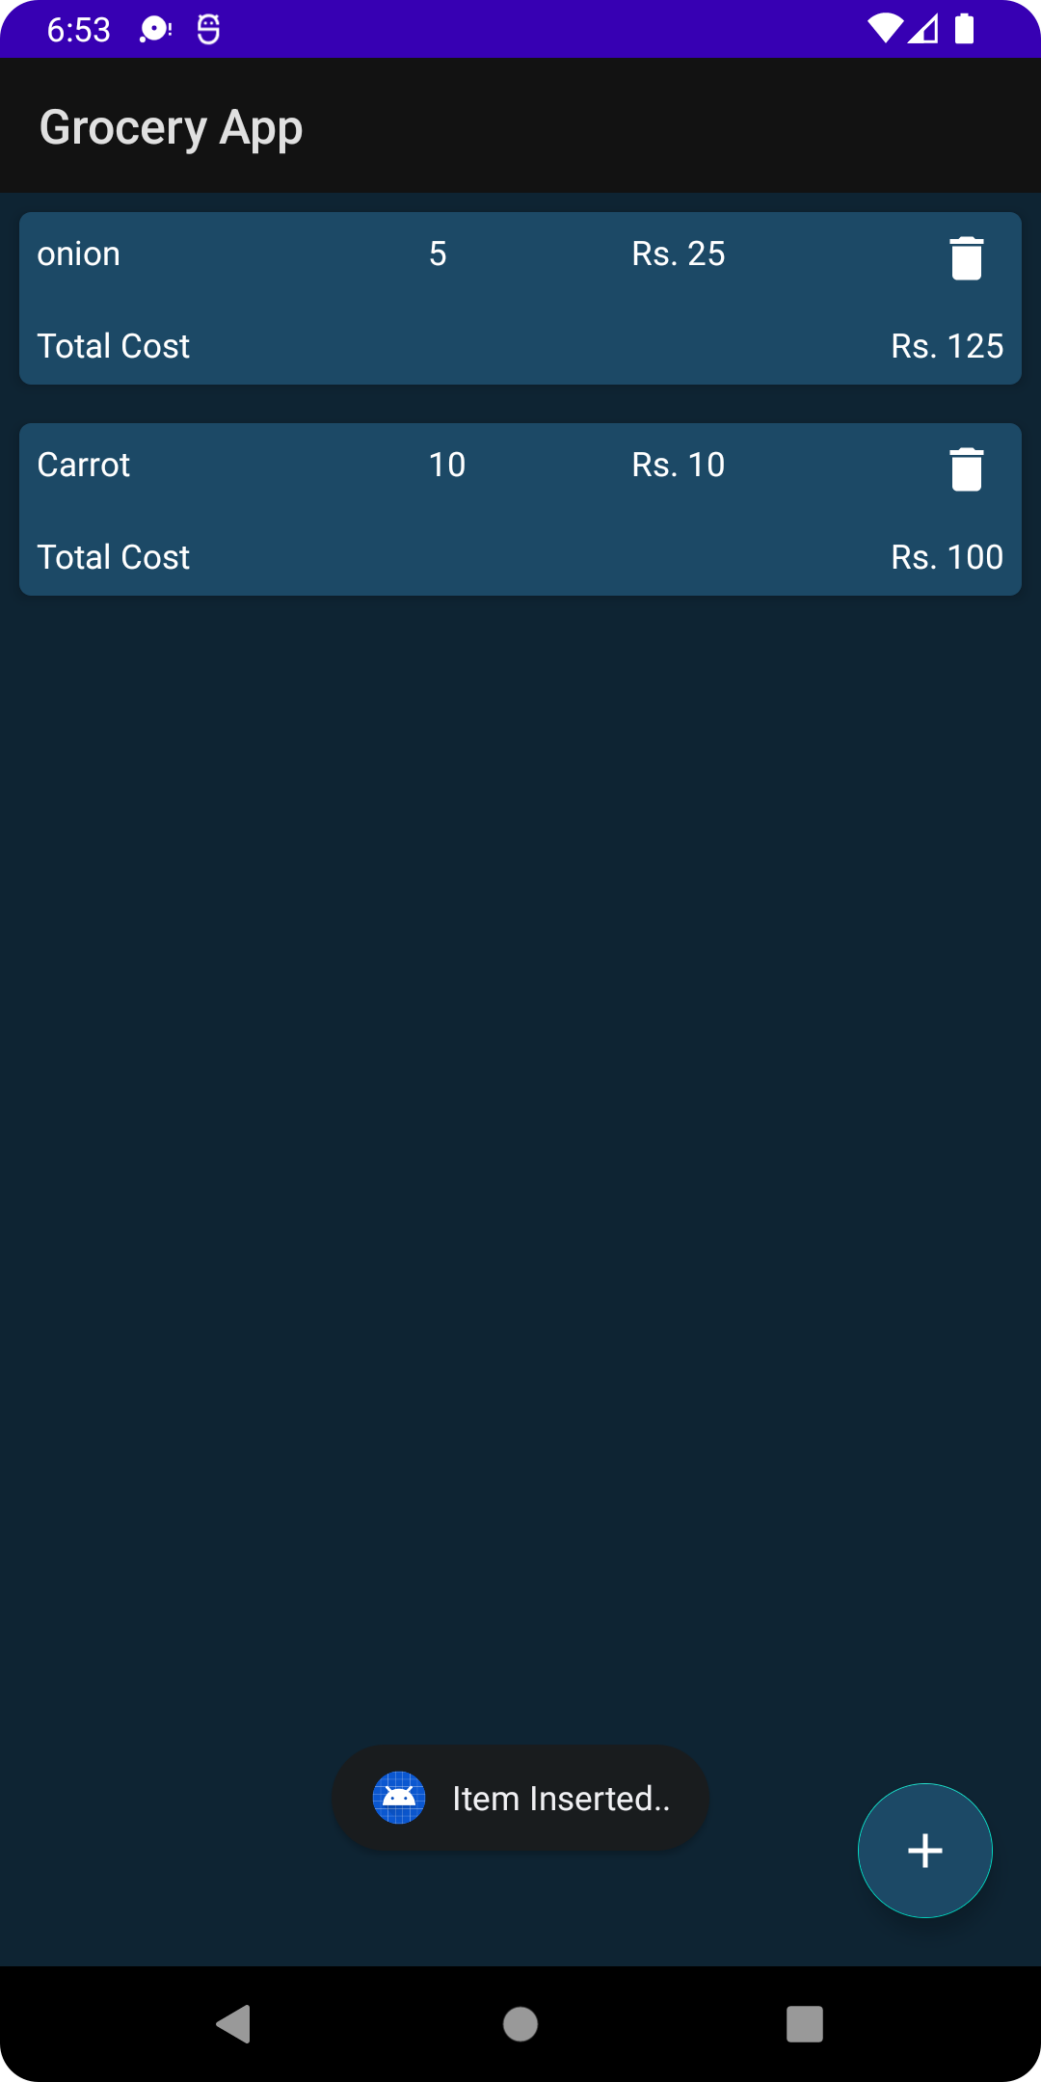**List preview with added up item**

# Advantages & Disadvantages

The application does help the user in remembering the list of groceries on one hand but on the other hand it calculates the total cost of items based on user input which might not be correct always.

# Applications

The application can be used by any age group in the society who have to buy grocery or create a list of items just in case they have a tendency to forget or have got a lot on their plate to remember.

# Conclusion

In conclusion, the application is easy to install and works eﬃciently. It helps users to form the list of items and also edit the list whenever they want. the users can also calculate an approximate amount of money they will be required to pay when they go shopping.

# Future Scope

The application can further be enhanced in future to fetch the rates of item via the internet and then calculate the total cost based on market trends.

# Bibliography

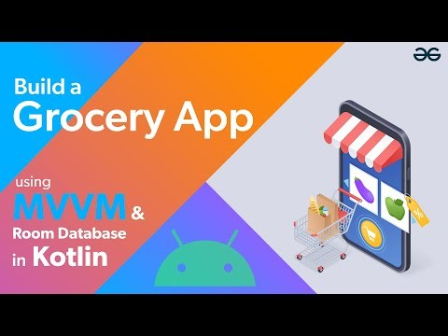

**Code**

https://github.com/Naman-Kakkar/Internship-AICTE.git